|  |
| --- |
| KANIJ FATEMA  Present Address- House Number: 132, Road No: 8, Block-F  Bashundhara, Dhaka  Cell phone: 01796582862  E-mail: limanis@outlook.com |

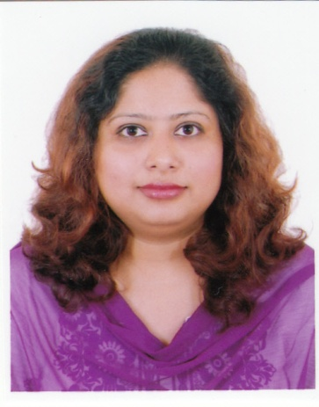

**Objective:** Looking for N.G.O, and other related job.

|  |  |
| --- | --- |
|  | |
| **Education** |  |
| Final Examination –  Date of Publication 2009.Session:2005-2006. | Master of Social Science(M.S.S) (Major in Anthropology)  University of Chittagong.Bangladesh.  CGPA: 3.38 on a scale of 4  Core Courses-Medical Anthropology, Basic Development Economics, Urban development |
|  |  |
| Final Examination-  Date of Publication 2008.Session:2001-2002. | Bachelor of Social Science (B.S.S) (Major in Anthropology)  Research Paper (Ship-breaking related)  University of Chittagong. Bangladesh  CGPA: 3.32 on a scale of 4  Core Courses-Gender, Sustainable development, Indigenous  knowledge and development etc. |
|  |  |
| Final Examination - 2000 | Higher Secondary Certificate Examination (H.S.C)  1st Division.  Major in Humanities.  Comilla Board.Bangladesh . |
|  |  |
| Final Examination  1998 | Secondary School Certificate Examination (S.S.C)  2nd Division.  Major in Humanities  comilla Board. Bangladesh. |
| Experience | |
| Oct 2014 – Jan 2015  2012 - 2014 | Conducted survey under Alliance, organized workshop and worked as interpreter at Phulki, an NGO situated in Bashundhara.  Stayed in New Zealand; worked as casual at the University of Canterbury And Community-based work. (e.g., child  care, create awarenesse about domastic violance, care of senior citizens.) |
| 2009 - 2011 | Nokia Excel Telecom Pvt Ltd. Chittagong.  Joniour H.R. Executive.  Responsibility-Multi-task work.  In my student life I workd as a research assistant in some filed projects, e.g., Care, UNICEF, etc. and workd in rural areas and with people from different cultural and ethnic backgrounds. |
| **Personal charateristics** | |
| Friendly, team player, sporty, loyal, commitment, can work long hours. I eagerly want to learn work.  **Personal Information**  Date of Birth : 01/02/1984.  Maritial Status: Married.  Nationality: Bangladeshi.  Religion: Islam.  **Other qualifications**  Computer literacy, Fluency in English. | |
| Reference  1. Sadaf Noor E Islam.  Associate Professor/Chairperson.  Dept.of Anthropology.  Chittagong University. | |

Chittagong.

Mobile Number :01818737896 .

2. Dr.Anisur Rahman Faroque.

Chairman and Assistant Professor.

Department of Marketing and International Business.

North South University, Dhaka.

Cell Phone: 01796582861.

Signature

Date